SOP: Roster Management (Admin and Super Admin)
Module | Roster Management (Admin and Super Admin)
Who uses it | Admin, Super Admin
Version | 1.0
Issued | 21 Oct 2026
Screenshots are taken from the HRMS test copy. Names, dates and numbers are examples only.

1. Purpose
Admins approve roster changes, control which weeks can be edited, send the weekly roster email, keep the holiday list and, when needed, reset rosters. Admins can also edit days exactly like managers (see SOP - Manager - Roster); their changes go through the same approval step.

2. Screen guide - admin controls
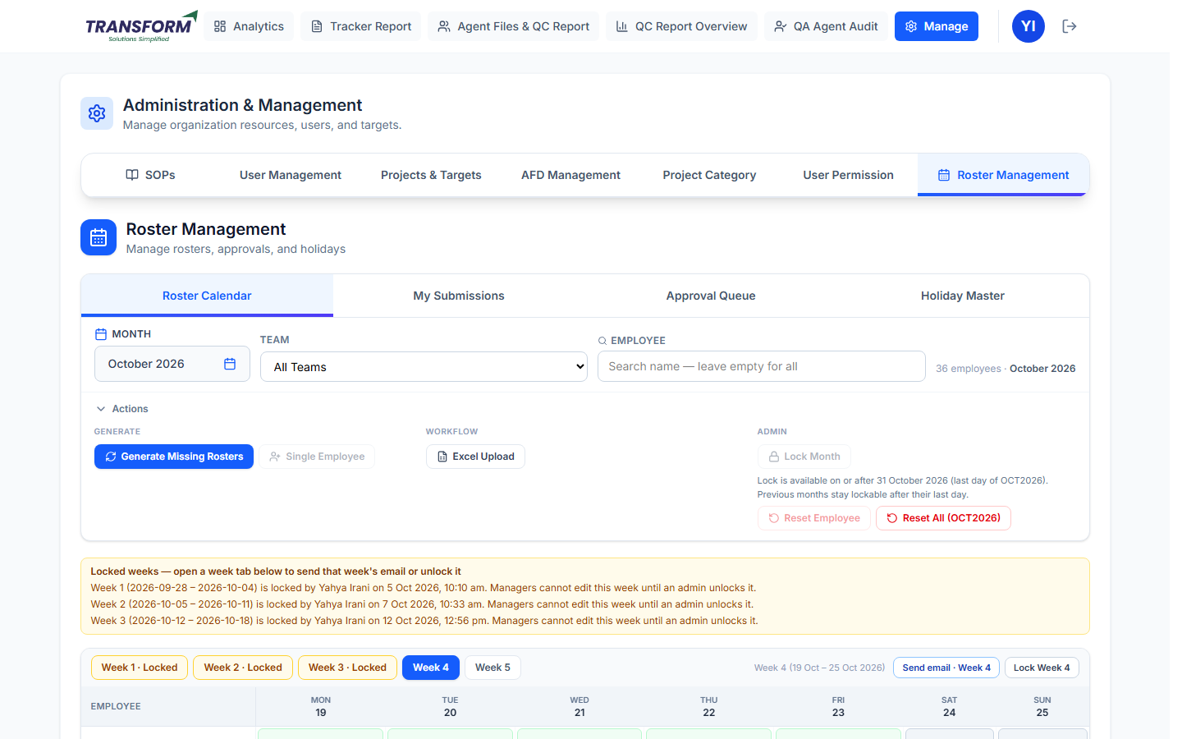
Figure 1: Roster Calendar - admin view
Control | Where | What it does
Send email · Week N | Right of the week tabs | Sends the roster email for that week only.
Lock Week N / Unlock Week N | Right of the week tabs | Stops or allows manager edits for that one week.
Lock Month / Unlock Month | Actions > Admin | Freezes or opens every week of the month. Lock Month is available from the last day of the month.
Reset Employee | Actions > Admin | Clears one employee's requests for the month and regenerates their roster.
Reset All (MONTH) | Actions > Admin | Deactivates every roster of the month, clears all request history and regenerates. Use only when the whole month is wrong.
Approval Queue | Tab | Approve or reject submitted changes.
Holiday Master | Tab | Add, edit, upload or deactivate holidays.

3. Procedure - Approve or reject changes
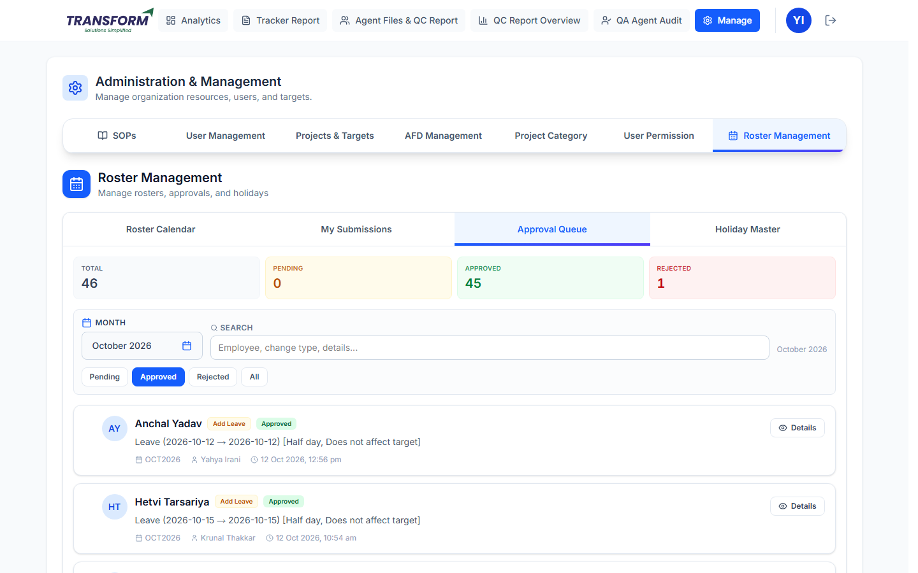
Figure 2: Approval Queue
1. Open Approval Queue. The cards show Total, Pending, Approved and Rejected for the month. Choose the Month, search, and use the Pending / Approved / Rejected / All filters.
2. Click Details on a request to see the employee, who submitted it and when, and the exact change (dates, leave type, half day, affects target, rostered).
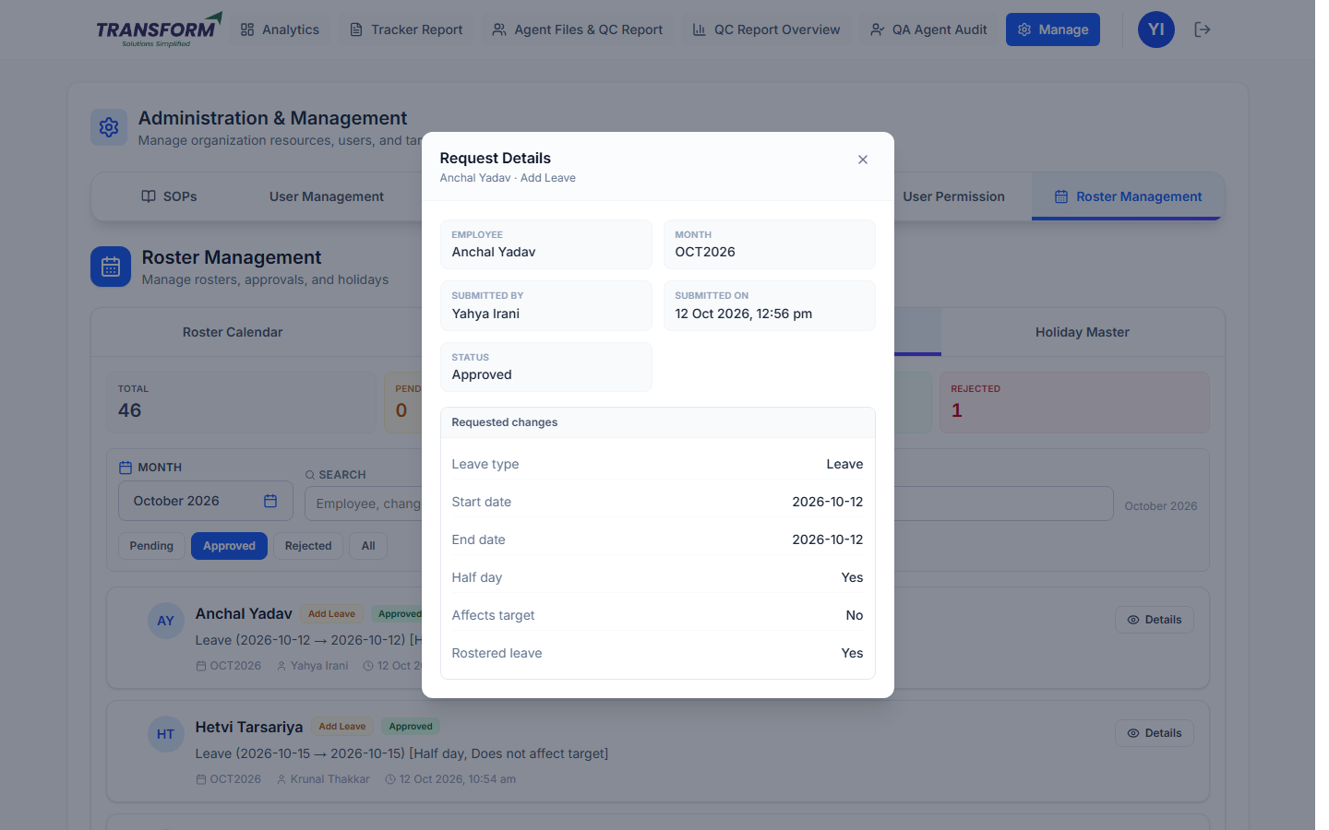
Figure 3: Request Details
3. Approve or Reject a single request, or tick 'Select all' / individual requests and use Approve (n) or Reject (n). Rejecting needs a comment.
4. Selected requests are applied oldest first, so if a day has two changes the later one is what remains.
5. After approval the change is applied, targets are recalculated and the weeks touched are locked.
6. Super Admin: 'Email approvers (pending)' emails Admin and Super Admin about pending requests.

4. Procedure - Lock, unlock and email a week
1. Open the week tab. To stop changes, click Lock Week N and Confirm.
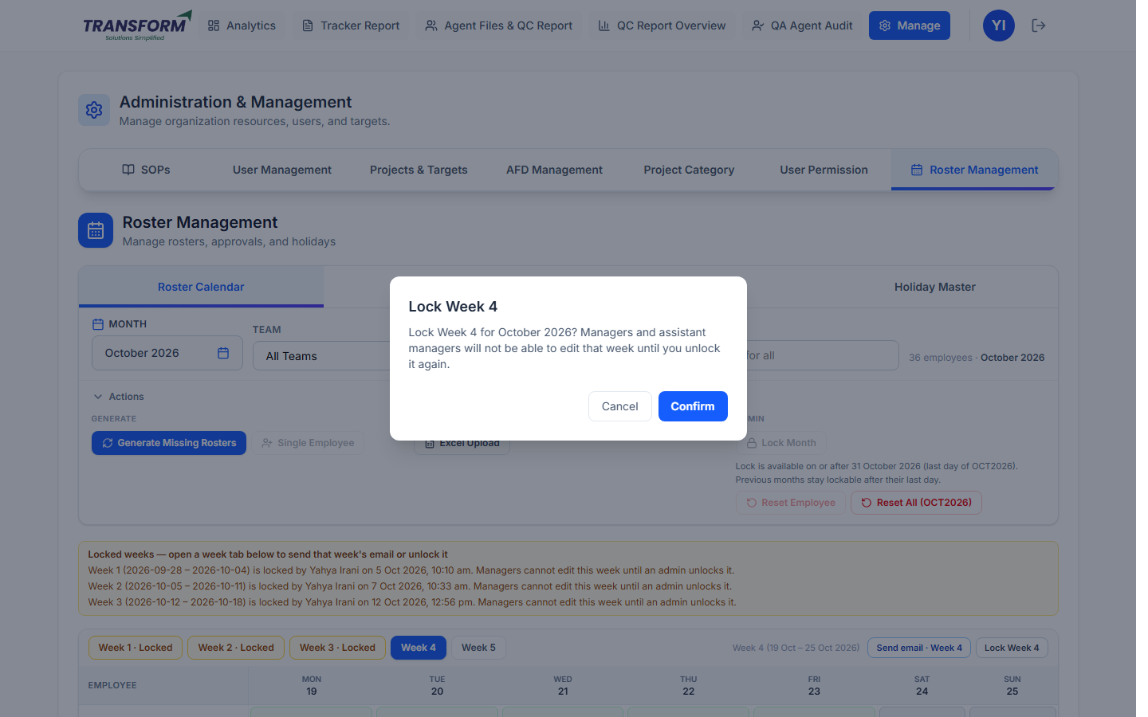
Figure 4: Lock Week confirmation
2. To let managers change a locked week, open it and click Unlock Week N. Other locked weeks stay locked.
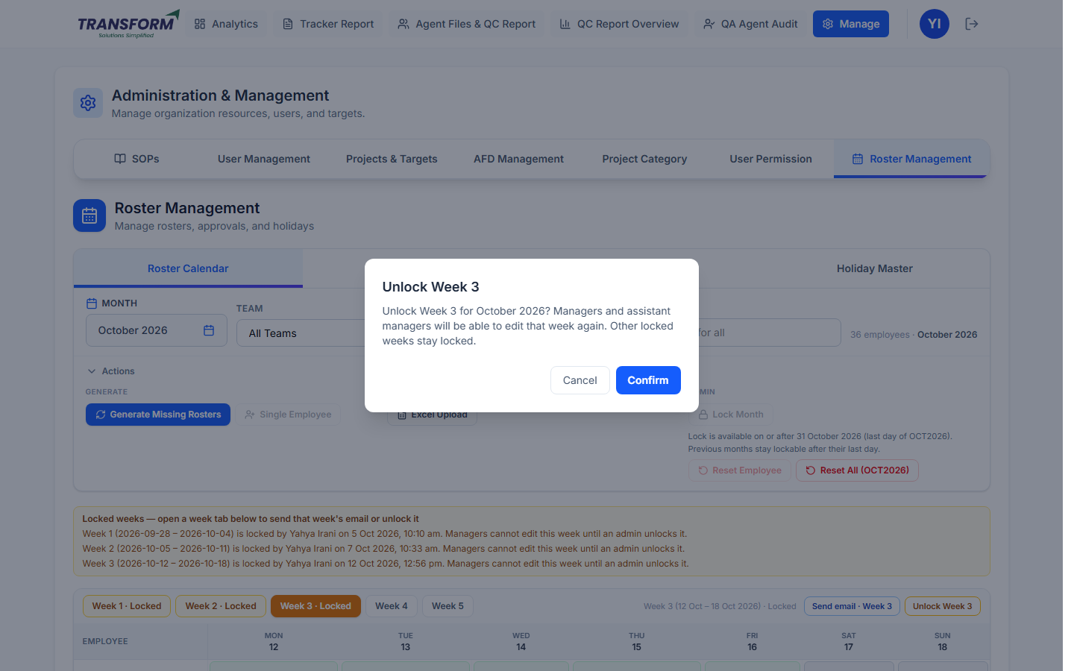
Figure 5: Unlock Week confirmation
3. When the week is final, click Send email · Week N and Confirm. Only that week is emailed.
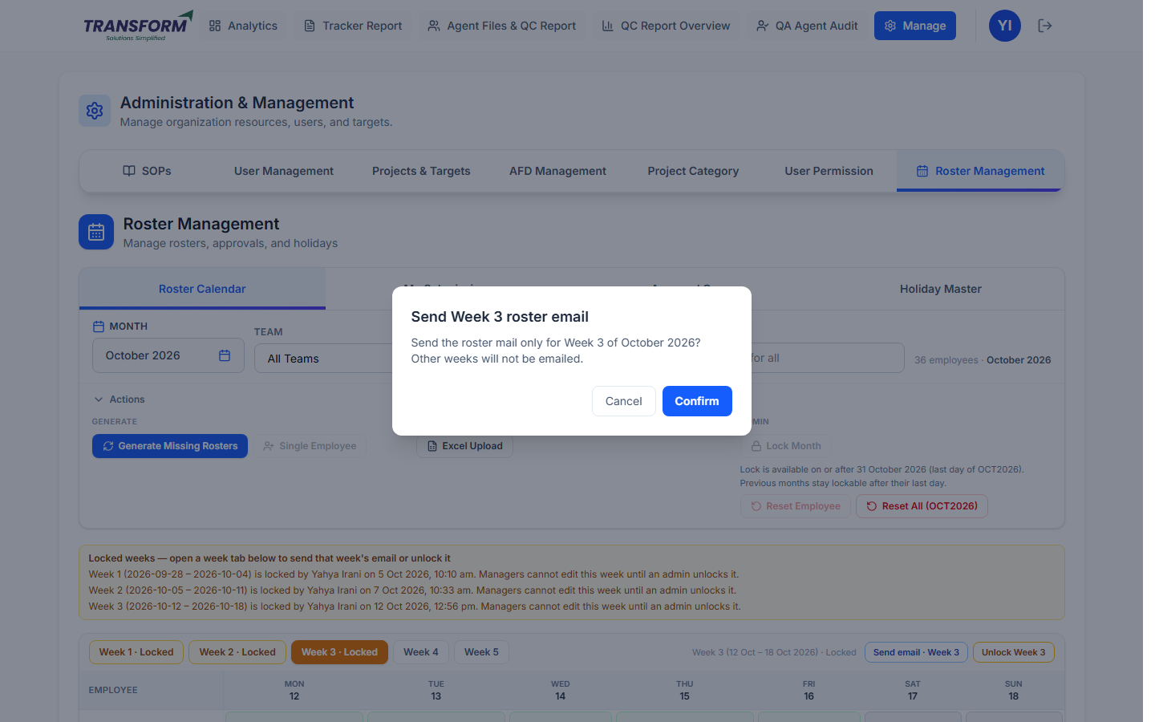
Figure 6: Send week roster email
4. Lock Month freezes the whole month (from its last day). Unlock Month or 'Unlock Calendar' on the banner opens it again.

5. Procedure - Reset rosters (use with care)
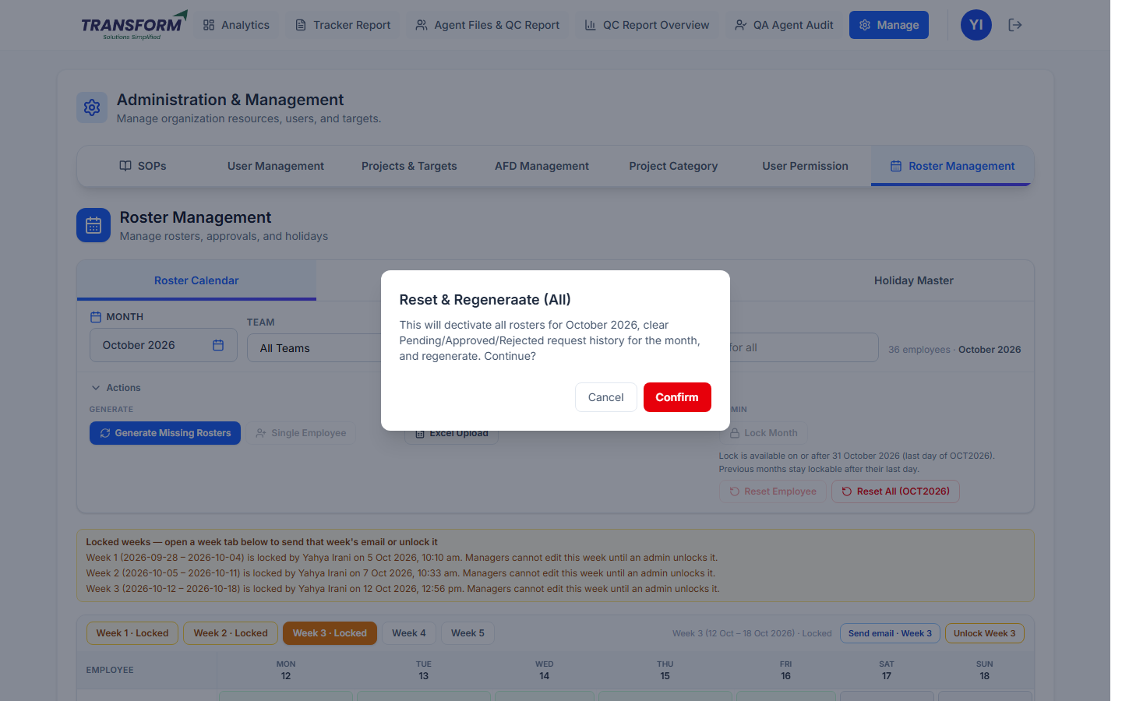
Figure 7: Reset All warning
1. Reset Employee: type the employee's name until only they remain, click Reset Employee and Confirm. Their requests for the month are cleared and the roster is rebuilt from their tenure and joining date.
2. Reset All: only when the whole month must be rebuilt. It clears every Pending, Approved and Rejected request for the month. It can take a minute; wait for 'Working...' to finish.

6. Procedure - Holiday Master
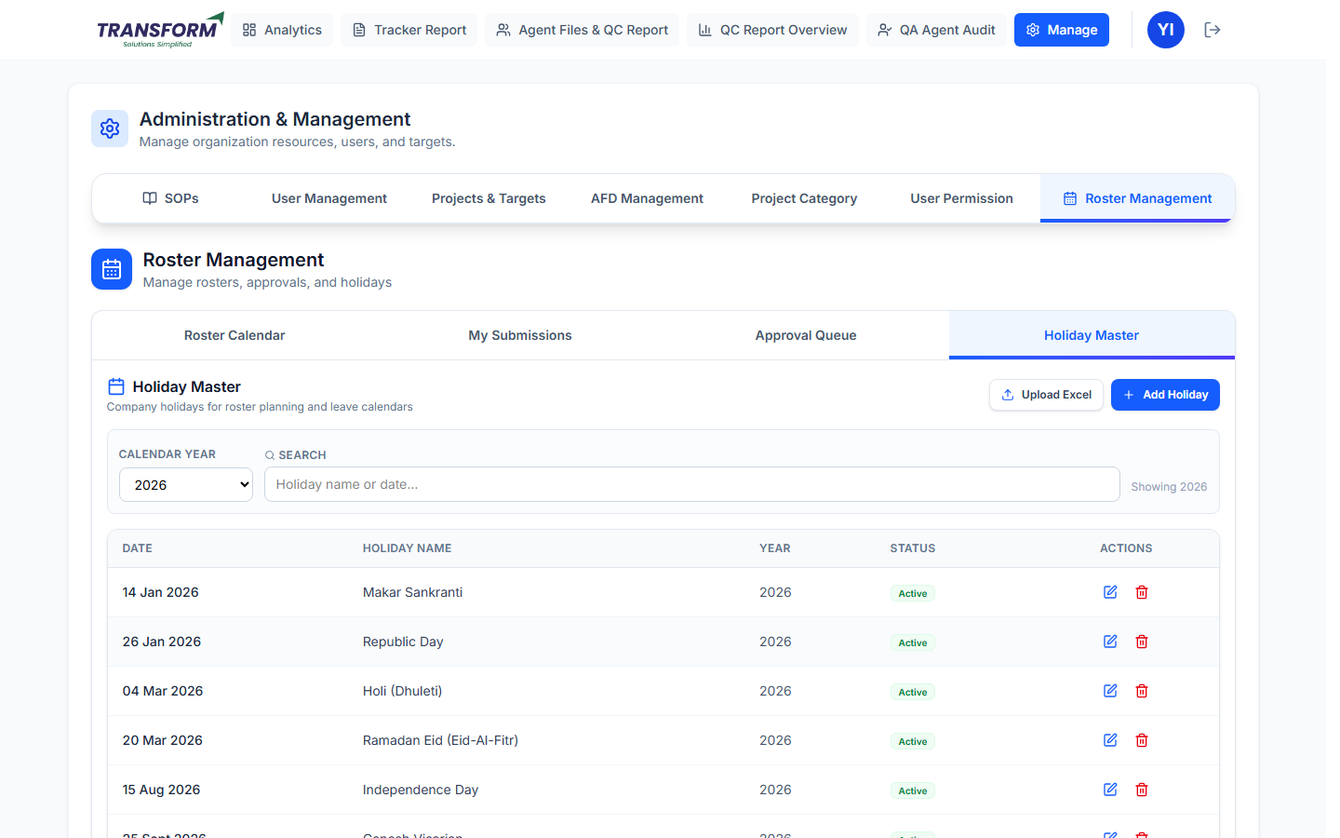
Figure 8: Holiday Master - admin
1. Click Add Holiday, enter the Holiday Name and pick the Date, then Save.
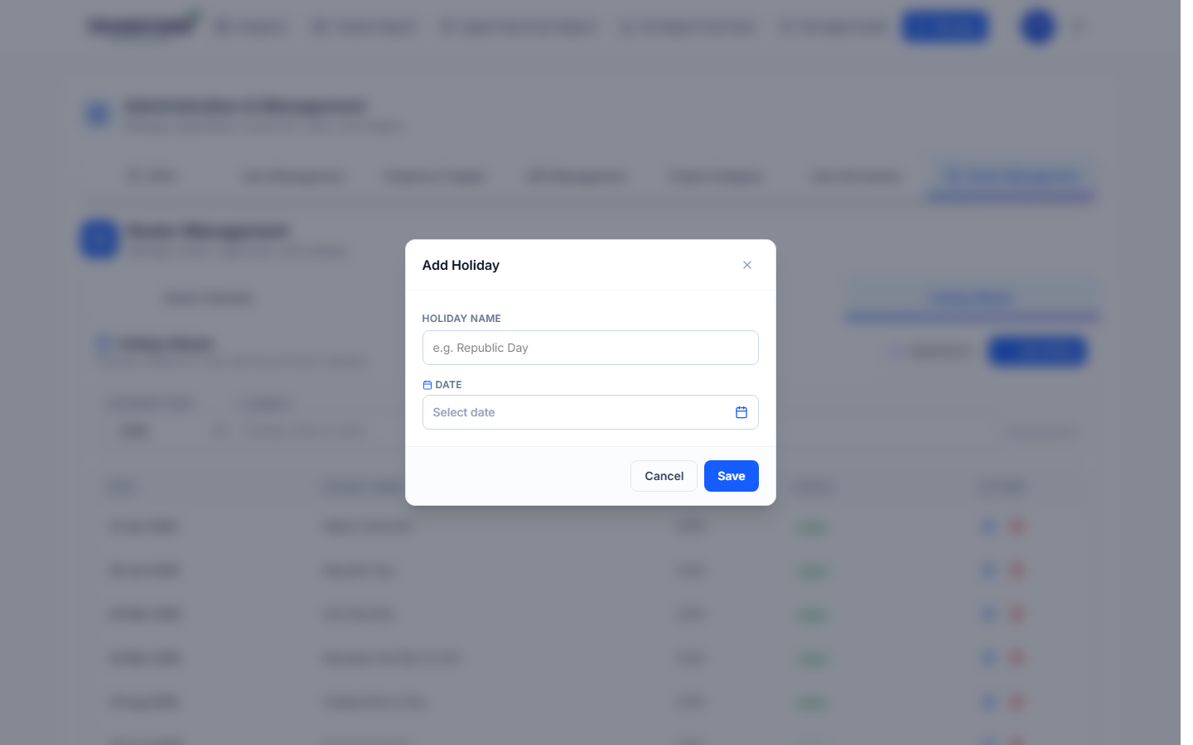
Figure 9: Add Holiday
2. Upload Excel adds many holidays at once. The edit icon changes a holiday; Deactivate removes it from rosters.
3. Holidays have the highest priority on a day. Leave and half day cannot be put on a holiday.

7. Admin editing days
- Click a day and use Edit Roster Day exactly as in the manager SOP. The change is a draft until it is submitted and approved - approve it in Approval Queue.
- Locked weeks block admins too. Unlock the week, make the change, then it locks again on approval.
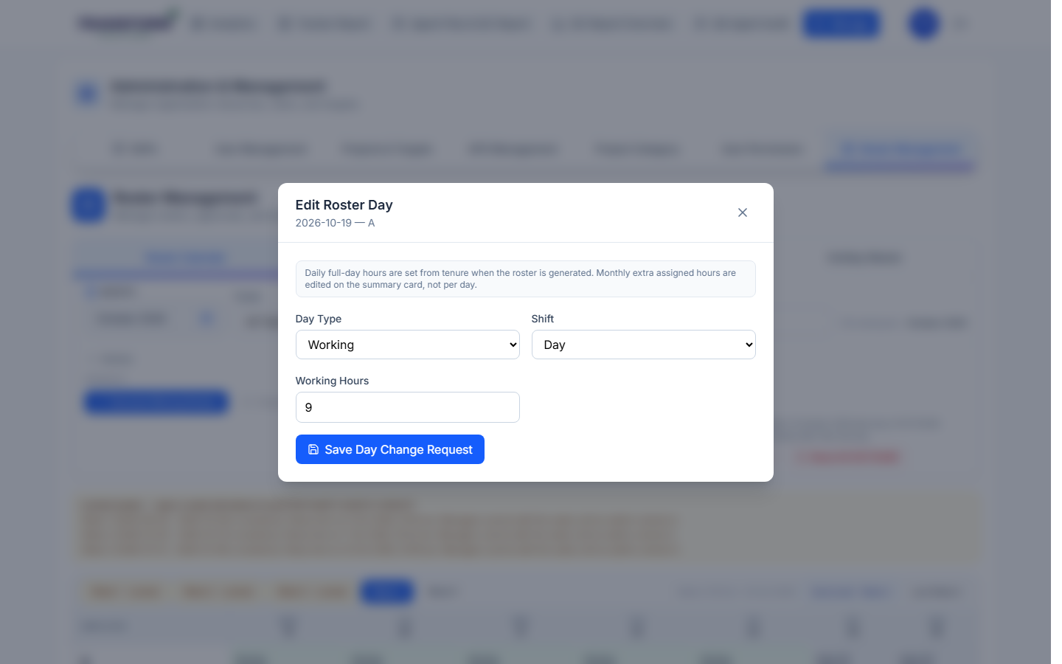
Figure 10: Admin editing a day

8. Common problems
Problem | What to do
Lock Month is greyed out | It opens on the last day of the month.
Manager says a week cannot be edited | Check the locked-weeks banner and unlock that week.
Weekly email not sent | The confirmation shows the reason. Check the week has approved rosters.
Two pending changes for the same day | Approve both together (latest wins) or reject the older one.

